1.INTRODUCTION

1.1 Overview

1.We are a travel agency and we use Zoho books for accounting.

2.We do not have any fixed price service or product and all our services like Air tickets.

1.2 purpose

1.Manage and access all your employee data from a centralized location.

2.Many leisure tourism trips are taken where the main purpose is relaxation rest and enjoyment.

2.PROBLEM DEFINITION & DESIGN THINKING

2.1 Empathy Map

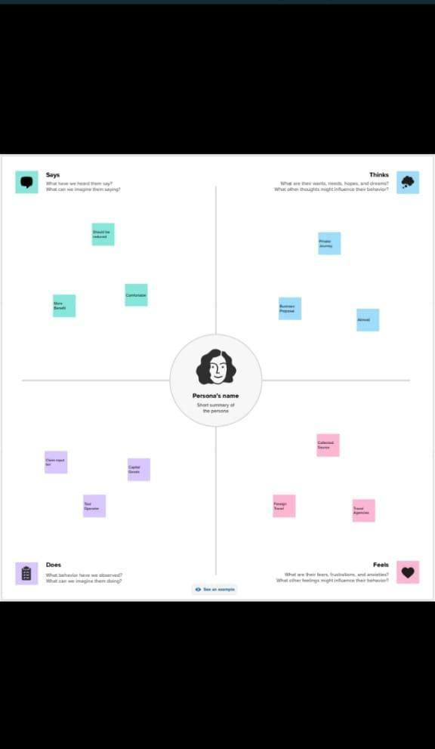

2.2 Brainstorming Map

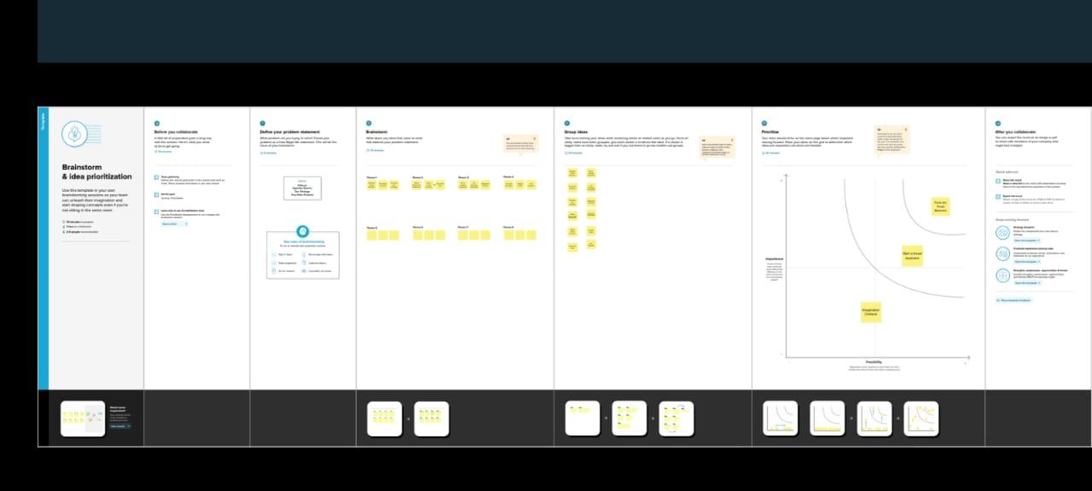

3.RESULT

Profit and loss was prepare for our business of loss or profit.

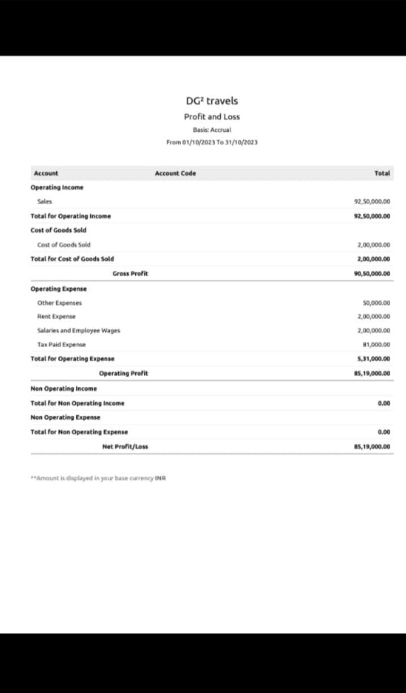

Balance sheet prepare for balance amount of a business

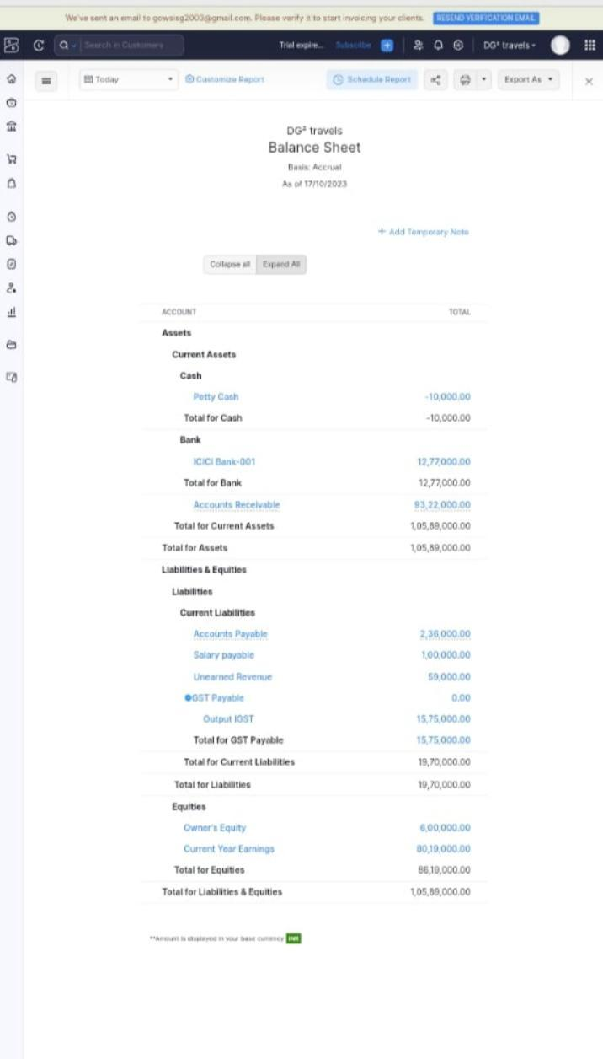

4.ADVANTAGES AND DISADVANTAGES

4.1 Advantage

1.In airlines or travel businesses with overseas bases , salaries are higher

2.The tourism industry give the country economic growth and stability

3.Enriches geographic identity globally

4.preventing it from collapsing during time of crisis

Disadvantage

1.people don't travel sustainably tourism can have many negative effects on any given area

2.flight and hotel can get very expensive unless you are ready to be very flexible with travel dates and compromise your time and comfort

3.It is also importaple to consider different currencies the rate of exchange

4.unequal distribution of income

5.APPLICATIONS

1.Some people have fantastic spatial awareness others not so such ,but most people have get lost atleast once in their life

2.It can be horrible feeling your heart beating faster as the pain starts to the rise

6.CONCLUSION

1.From personal growth and rejuvenation to professional development and networking

2.Travel can provide us with an array of benefits that can enhance our lives in countless ways

7.FUTURE SCOPE

1. Endless job opportunities that candidates can avail in both private and public sectors after pursuing travel and tourism courses